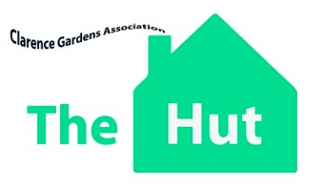

Bringing creativity and purpose to the lives of adults with Mental Health and/or Learning Disabilities
Charity Number: 1147146
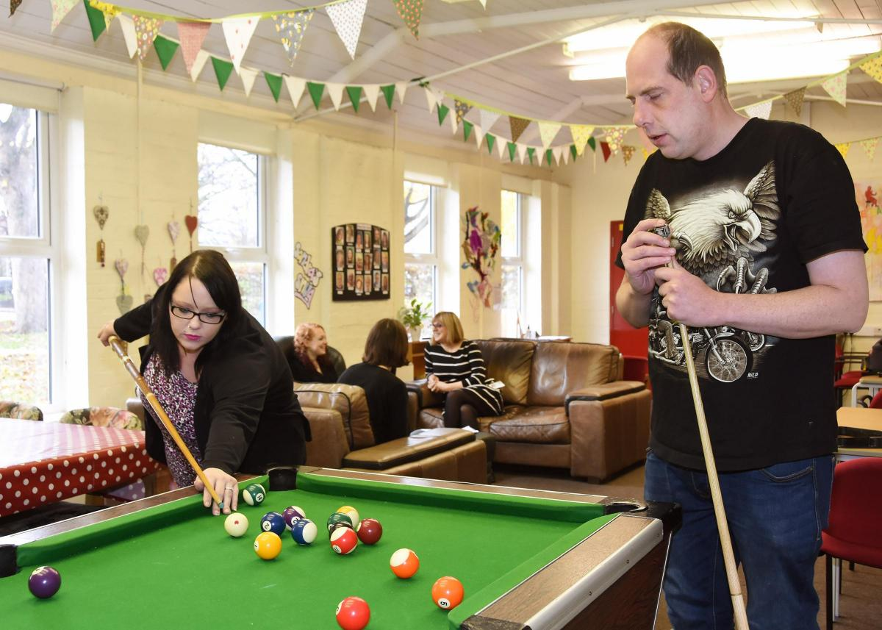
The Trustees would like to invite you to the
Annual General Meeting
Tuesday 20th June 2017
6-7 pm
The Hut, Wigginton road, YORK YO31 8HG
(Just opposite York Hospital care park)
thehutyork.co.uk info@thehutyork.co.uk 01904 652991

