Monday | Tuesday | Wednesday | Thursday | Friday
11.154tam  Monday Movement & Relaxation  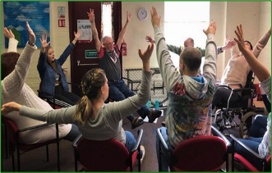 | 11.15am  Games Morning  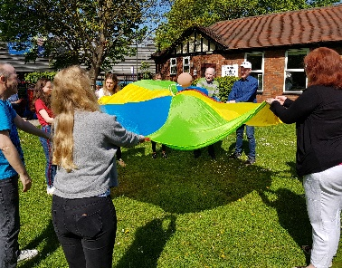 | 11.15am  Music Workshop  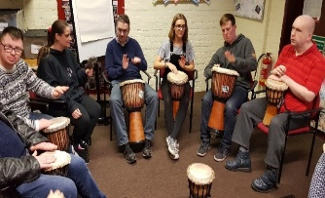 | 11.15am  Exploring Nature Workshop  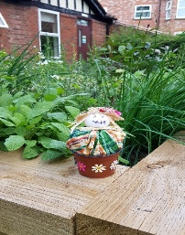 | 11.15am  Hut Scribes (Creative Writing)  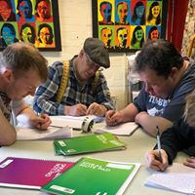
Lunch  12.15-1.15 | Lunch  12.15-1.15 | Lunch  12.15-1.15 | Lunch  12.15-1.15 | Lunch  12.15-1.15
1.15pm  Art Workshop  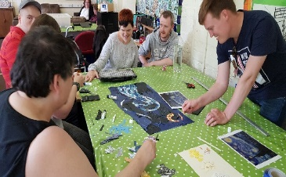 | 1.15pm  Card Crafting Workshop  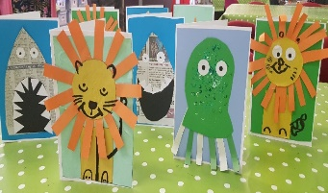 | 1.15pm  Crafting Workshop  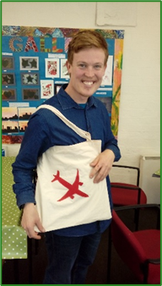 | 1.15pm  Food Workshop  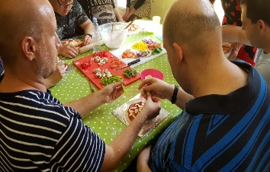 | 1.15pm  The Hut Gameshow with Max  