New August 2021Timetable for The Hut Sessions
Early Morning Session:  10.30-11.00 | Monday | Tuesday | Wednesday | Thursday | Friday
Morning Session:  11.15-12.45 | Monday Movement | Creative Art  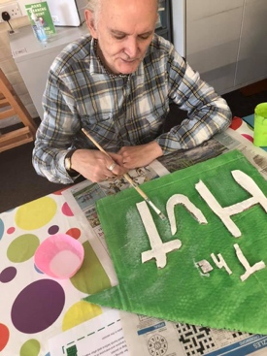 | Sculpture Club | Exploring Nature/ Food Glorious Food (Winter)  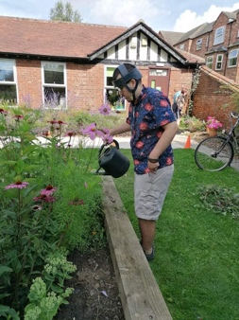 | Hut Scribes  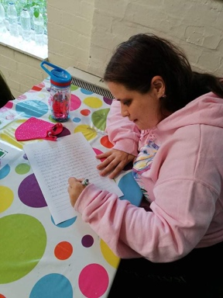
Lunch Session:
12.15-1.15
Afternoon Session:  1.15-3.00 | Some kind of drawing  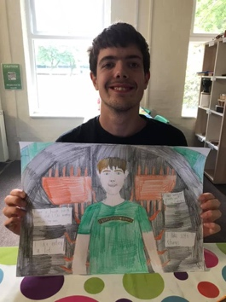 | Fun With Fabrics  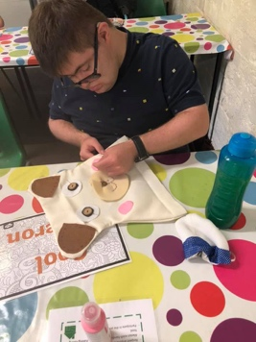 | Anything goes Crafts | Musical Minds  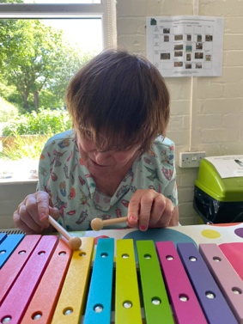 | Fun & Bingo Games

Timetable for The Hubble Sessions
Hubble Health early starts:  10.20-11.00 | Monday  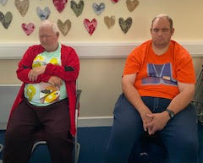  Monday Mindfulness | Tuesday  Hut Singalong  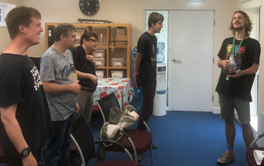 | Wednesday  Midweek Meditation  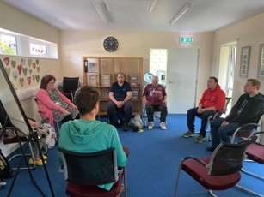 | Thursday  Body Tapping  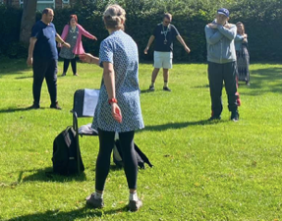 | Friday  Take a Breather
Morning Session:  11.15-12.45 | 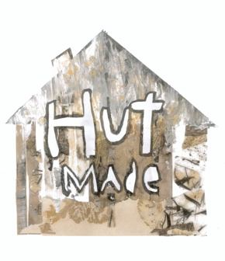  Hut Made  Social Enterprise Group | My Journey  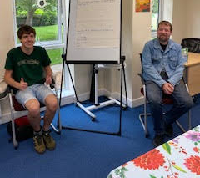 | Stepping Stones | Hearing Voices  (11-12:30)  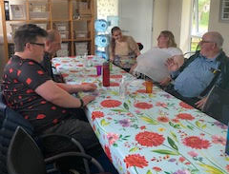
Lunch Session:  12.15-1.15 |  | 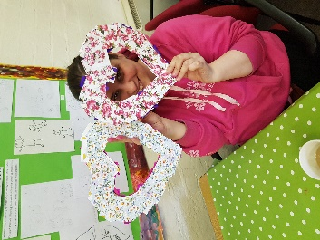  Women’s Hour | Members Meeting  (Monthly) | Men’s Lunch Club  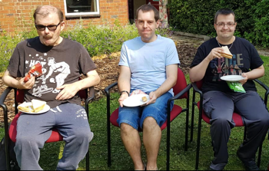
Afternoon Session:  1.15-3.00 | 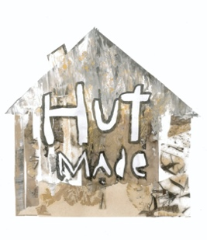  Hut Made  Social Enterprise Group | Hut Made  Social Enterprise Group | Umbrella Support Group (Monthly) | Lifeology

