Open 10-4 | Monday | Tuesday | Wednesday | Thursday | Friday
10-12  (Coffee, Tea and Water are available10-3.30) | The Hut Social  ‘Monday Movement’ 11-12 with Ian  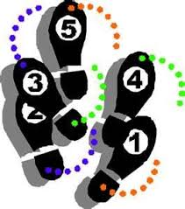 | Drop in for new members 10-12  11-12 Activities  ‘My Journey’ 10.15-11.30 | The Hut Social  Games  & wellbeing day | Drop in for new members 10-12  11-12 Activities | The Hut Social  Crafts  11-12
12-1.15  (We all like to sit and have lunch together) | Lunch | Lunch  ‘Men’s Lunch Club’ 11.45-12.45 | Lunch | Lunch | Lunch
1.15-3.15  Break 2-2.15  (We close at 4pm) | Art Workshop with Jonny | Crafts | Games day continues  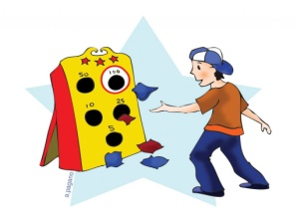 | Crafts with  ‘The Hut Scribes’ 1.15-2.15pm With Emma | Crafts

