Timetable for The Studio
 | Monday | Tuesday | Wednesday | Thursday | Friday
Morning Session:  11.15-12.45 | 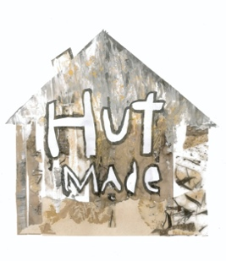  Hut Made Social Enterprise – Em | Crazy Collage – Em  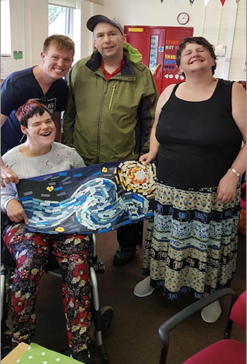 | Sculpture Club – Em and Tom  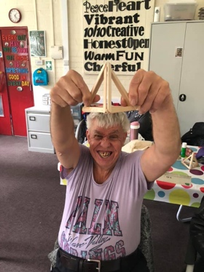 | The Great Outdoors – Edd and Tom  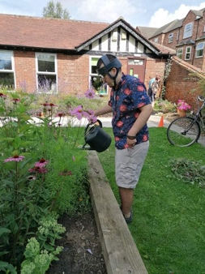 | Hut Made Social  Enterprise – Em
Afternoon Session:  1.15-3.00 | Hut Made Social E  Hut Made Social Enterprise – Em | 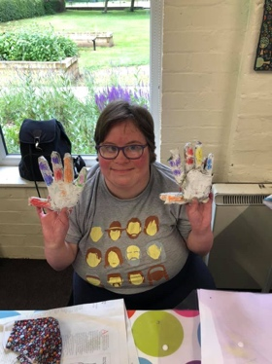  Anything Goes Crafts – Lauren | Creative Art – Em and Tom  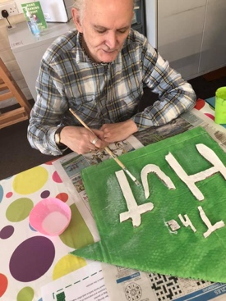 | Musical Minds – Edd  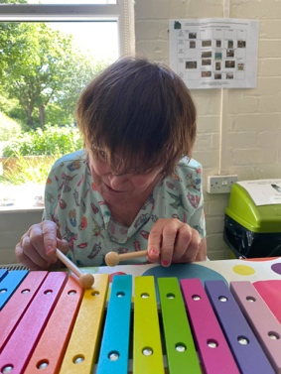 | Fun & Bingo – Tom  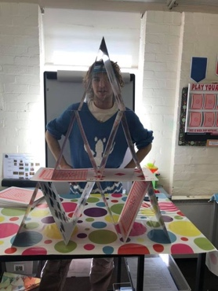

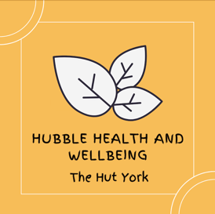
Timetable for The Hubble Health and Wellbeing Programme
Hubble Health early starts:  10.30-11.00 | Monday  Hubble Singalong – Ian  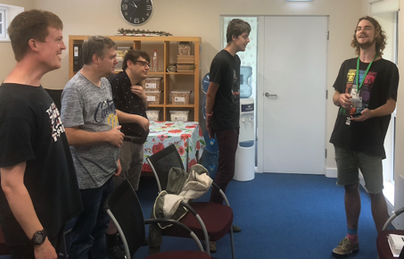 | Tuesday  Laughter Journaling – Emma  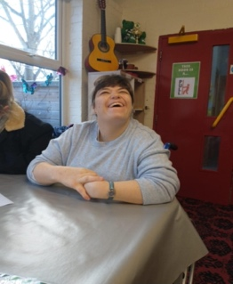 | Wednesday  Midweek Meditation – Tom  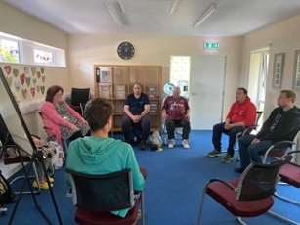 | Thursday  Body Tapping – Em  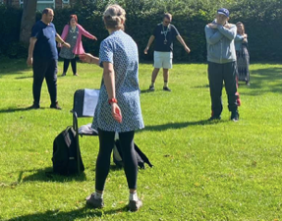 | Friday  Take a Breather – Edd  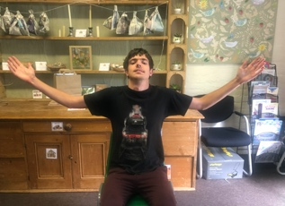
Morning Session:  11.15-12.45 | Monday Movement – Ian and Tom  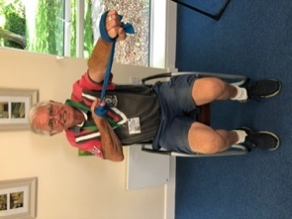 | My Journey – Emma and Edd  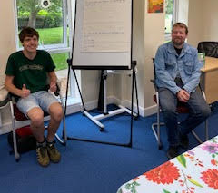 | Stepping Stones – Emma | Hearing Voices  (10:30-12:00) – Toby  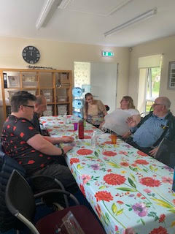 | 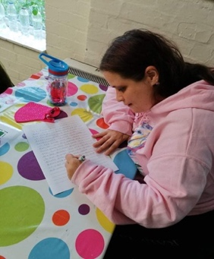  Hut Scribes – Tom
Afternoon Session:  1.15-3.00 | Some Kind of Drawing – Tom  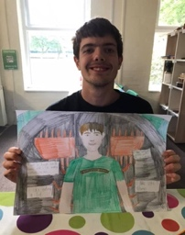 | Let’s Talk (Men’s Group) – Tom  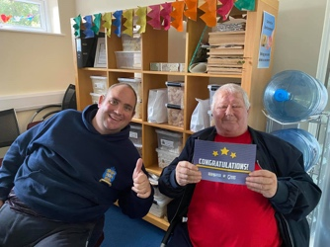 | Umbrella Support Group (Monthly) – Emma and Em | Lifeology – Emma

